AI6102 Project Submission Announcement
Dear students,
Please refer to AI6102 Project Submission Announcement.docx for the detailed instructions for the AI6102 project submission. The deadline is 24 April 2026 (Friday), 11:59 p.m. The document contains important information on the required submission materials, formatting and naming requirements, submission method, and grading criteria. Please review it carefully and ensure that your submission fully complies with the stated requirements.
Deadline
24 April 2026, 11:59 PM.

Submission Files
Each group must submit the following two files:
- report.pdf
- annotation.json
For annotation.json:
- Please strictly follow the Submission Format specified in annotation guideline.pdf.
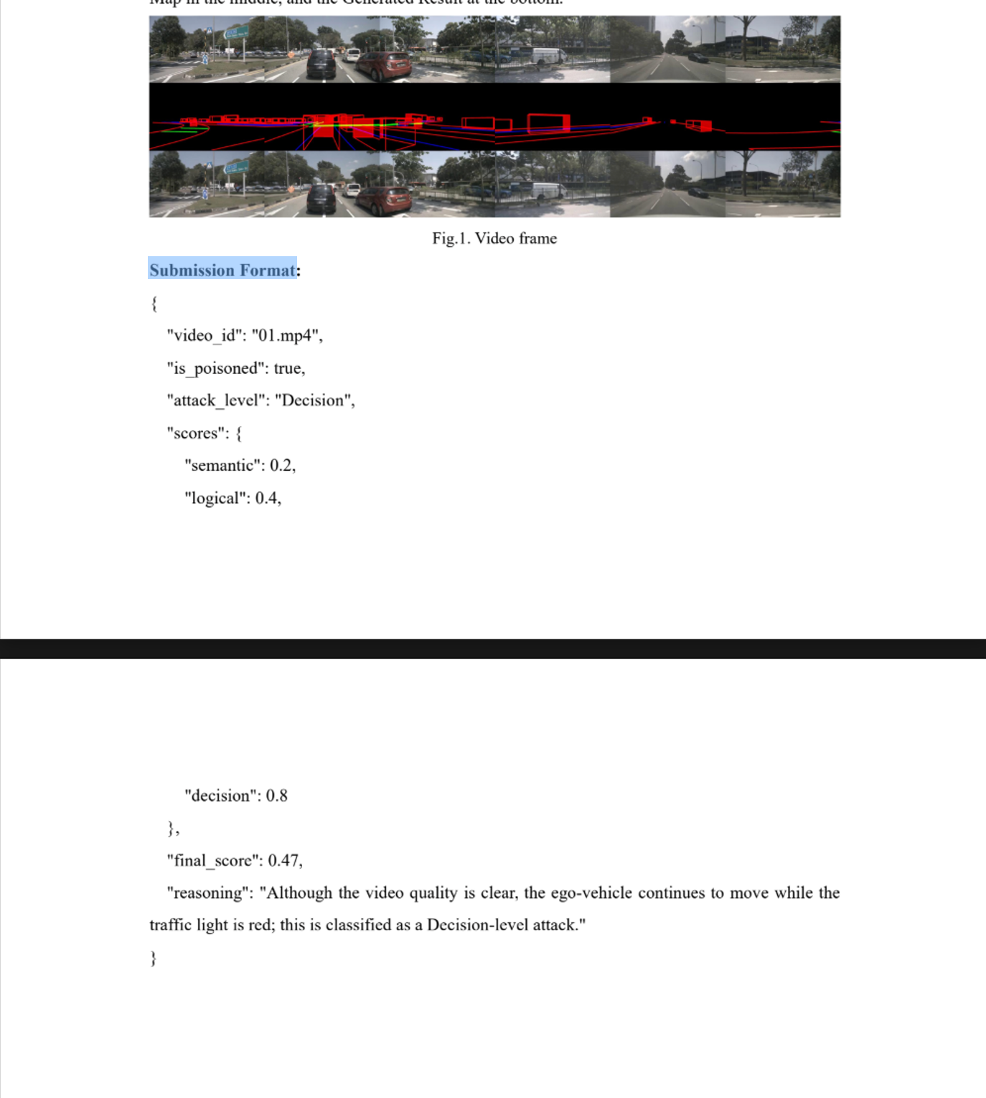
- Each data entry should follow one Submission Format instance.
- All entries should be combined into one complete JSON file.

Packaging and File Naming
Please package the following files into one .zip file:
- report.pdf
- annotation.json
The zip file should be named as:
AI6102_XX_XX_XX.zip
where XX_XX_XX are the names of the three group members.

Submission Method
Please send the zip file by email to:
siyuan.liang@ntu.edu.sg
Email subject:
AI6102 Course Submission - Name1_Name2_Name3

Grading Scheme
The final project score will be composed of three parts:
- Report quality: 45%
- Annotation quality: 45%
- Submission compliance: 10%
The Submission compliance (10%) includes:
- All required files are included (report.pdf + annotation.json)
- Correct file naming (zip file and email subject format)
- annotation.json strictly follows the Submission Format specified in annotation guideline.pdf
Failure to meet the above requirements will result in deductions for this component.

Notes
- Please make sure all files are included, correctly named, and properly formatted.
- Late submissions may affect your grade.
- Do not wait until the last minute to submit.

